**GRACIOUS GARMENTS REPORT**

**AYESHA SHAFIQUE**

**Objective:**

Gracious Garments is a clothing company that sells a variety of garments for both men and women. The company currently advertises its products via pamphlets, television ads, and other traditional methods. However, with the rapid growth of the internet, the company has decided to launch a website to enhance customer interaction and facilitate easy access to product information. The website will serve as an online portal where customers can explore the various products offered by Gracious Garments, learn more about the products, and contact the company.

**Output :**

**LANDING PAGE**

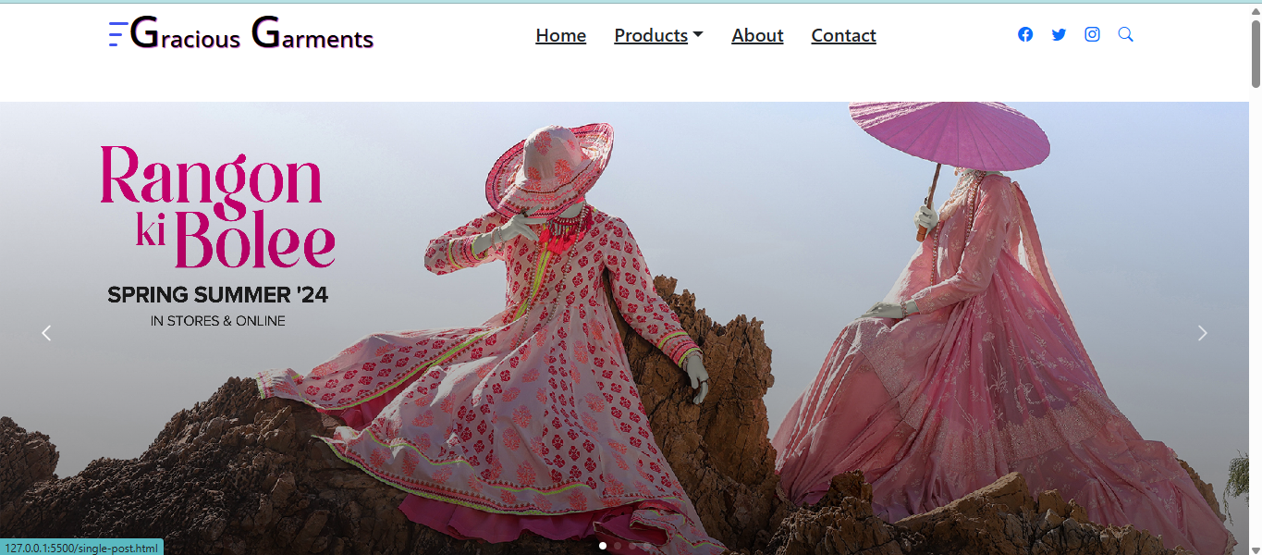 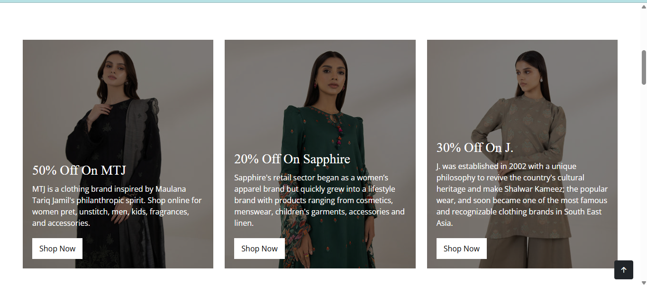 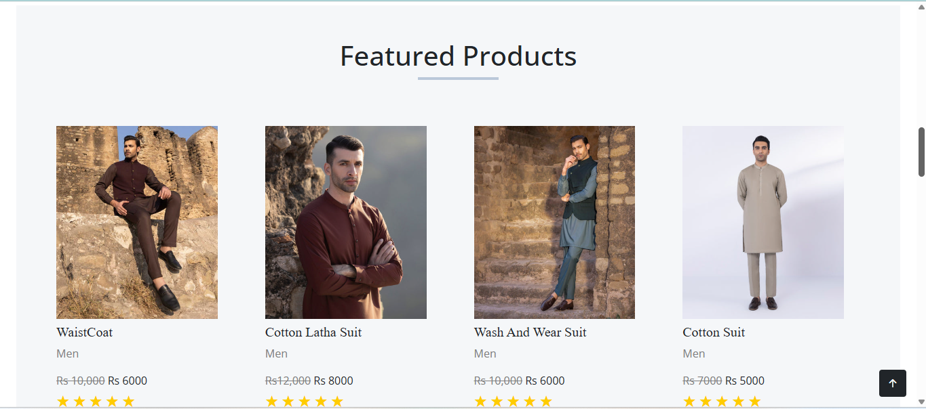 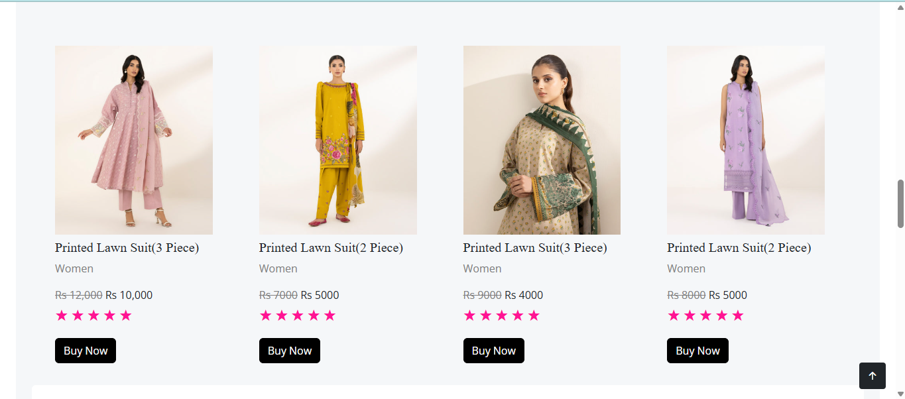 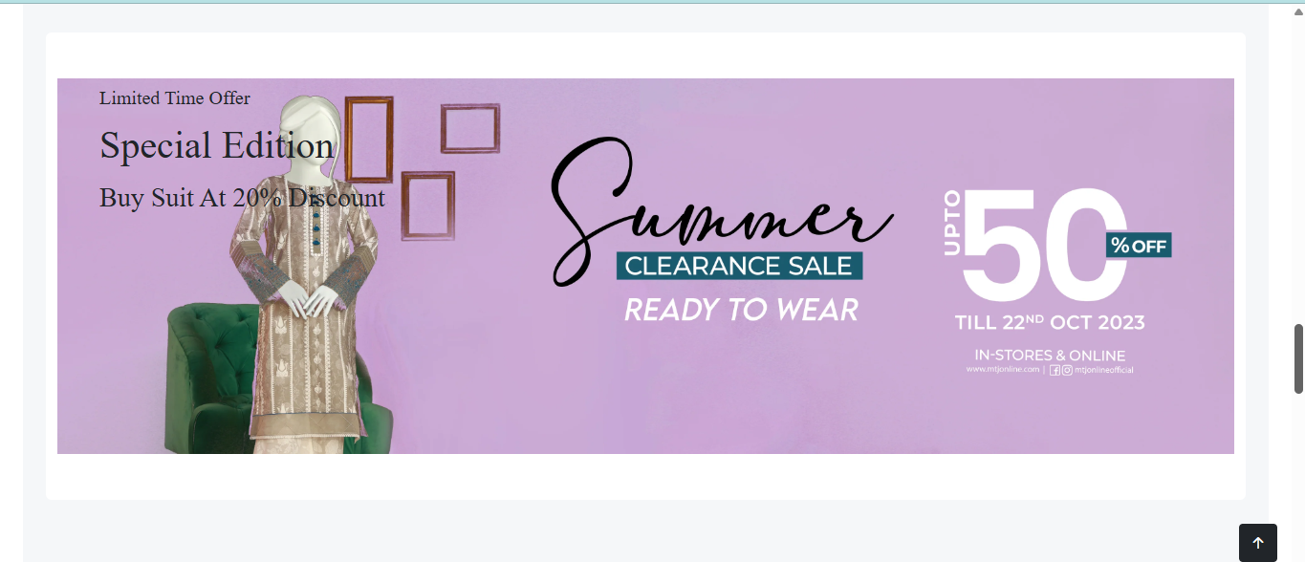 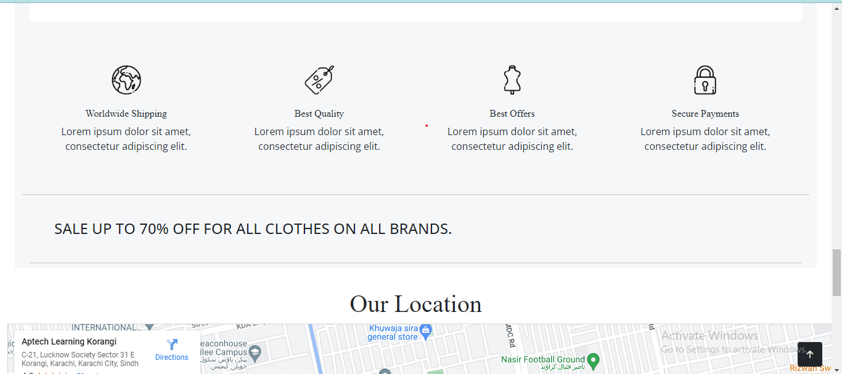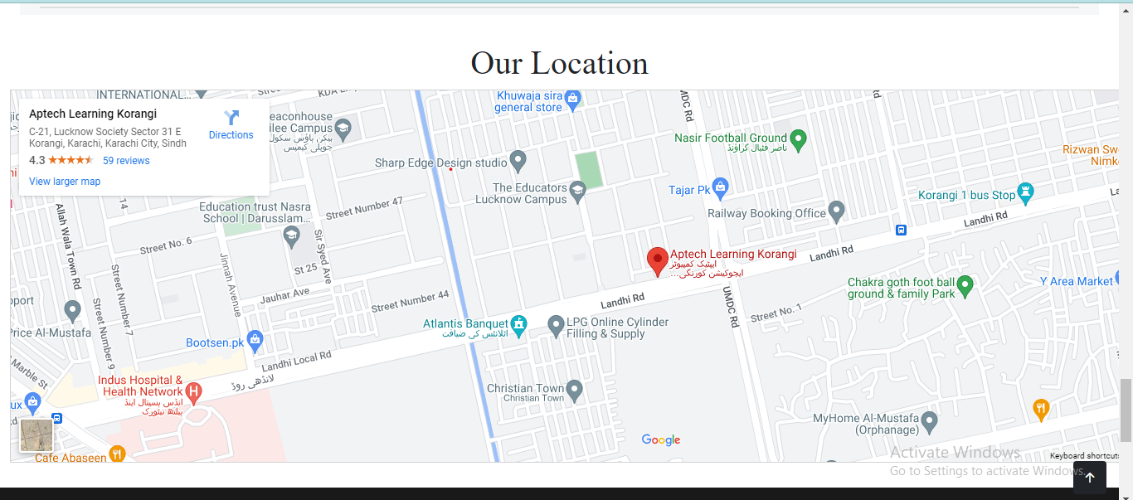

**FOOTER**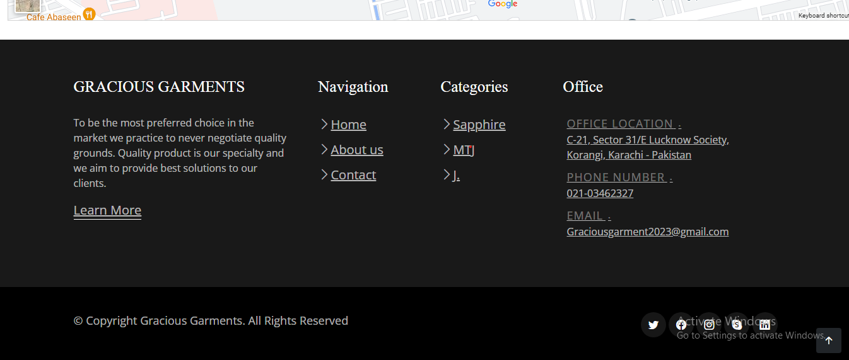

**PRODUCTS**

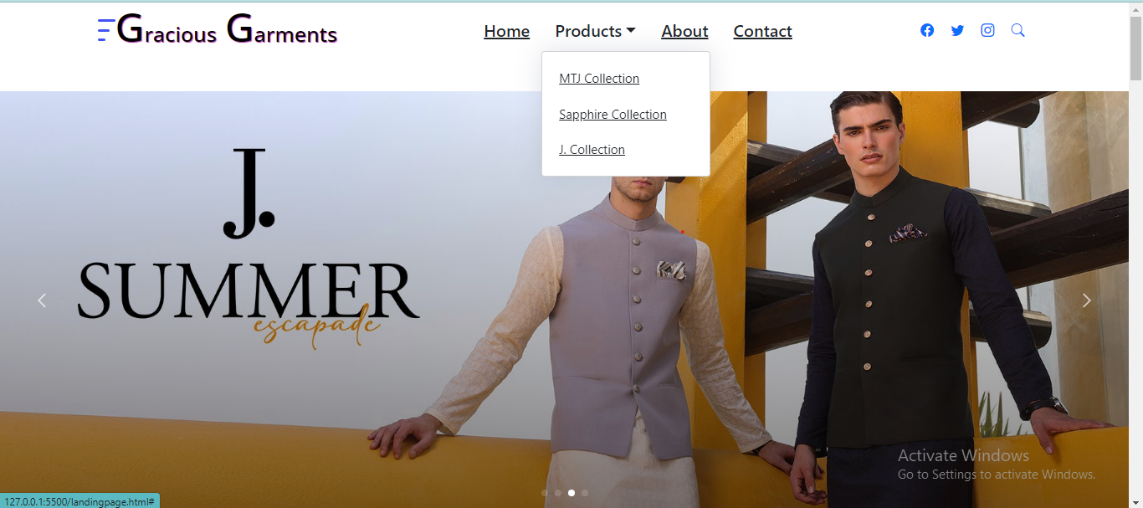

**MTJ PRODUCTS** 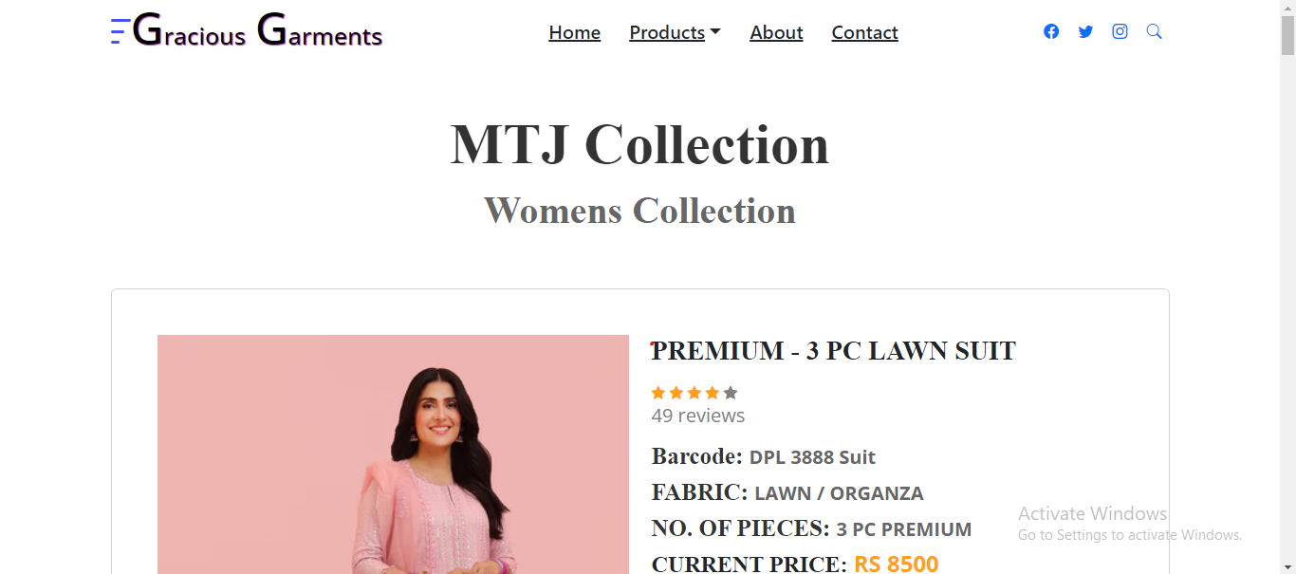 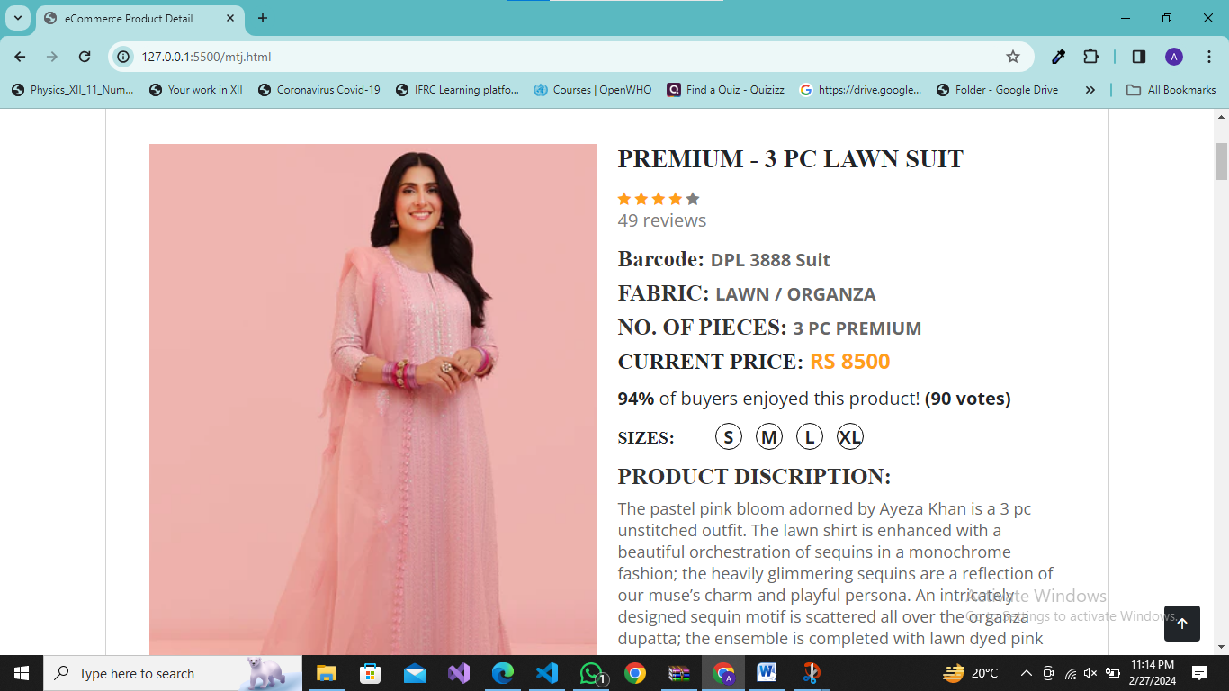 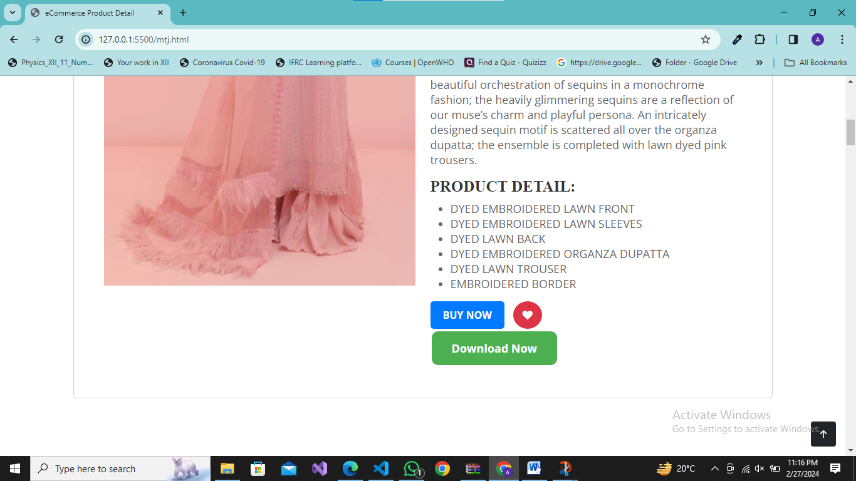 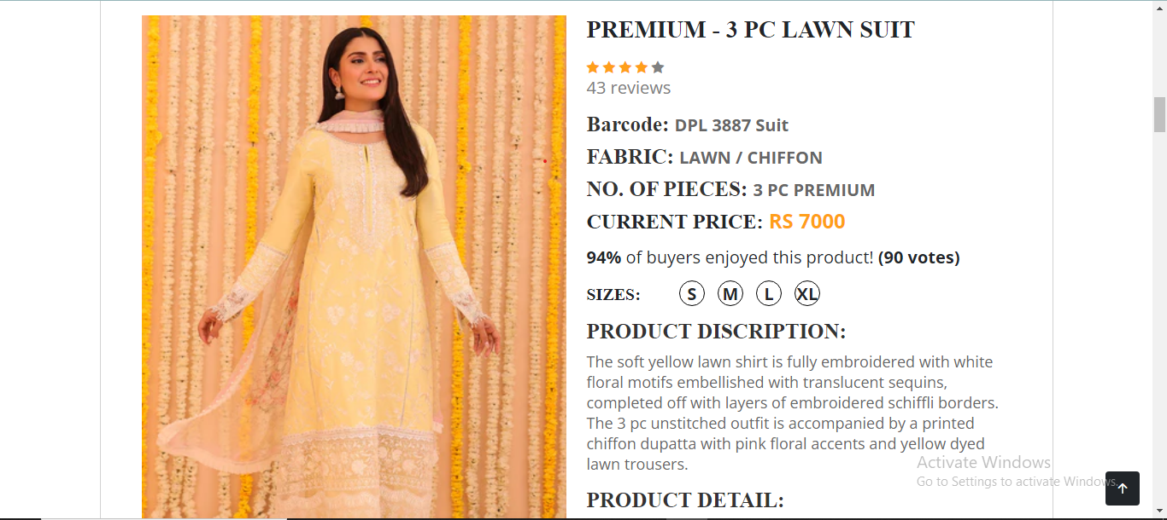 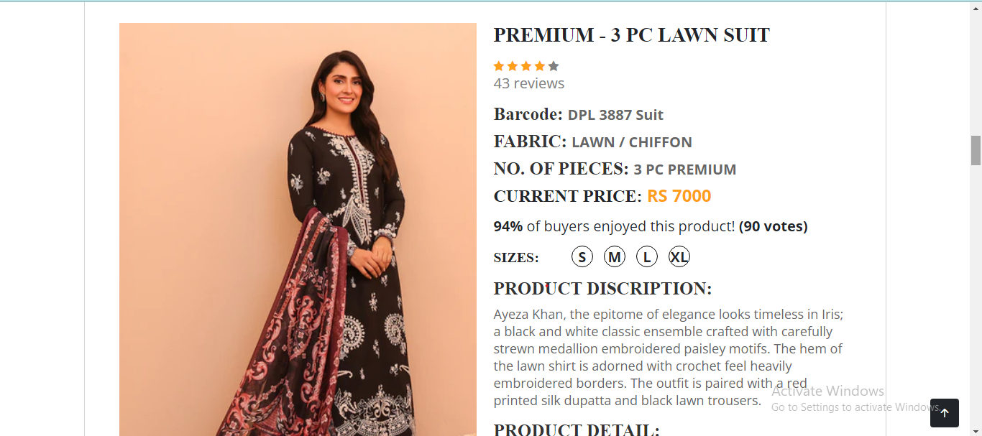 **ABOUT US  
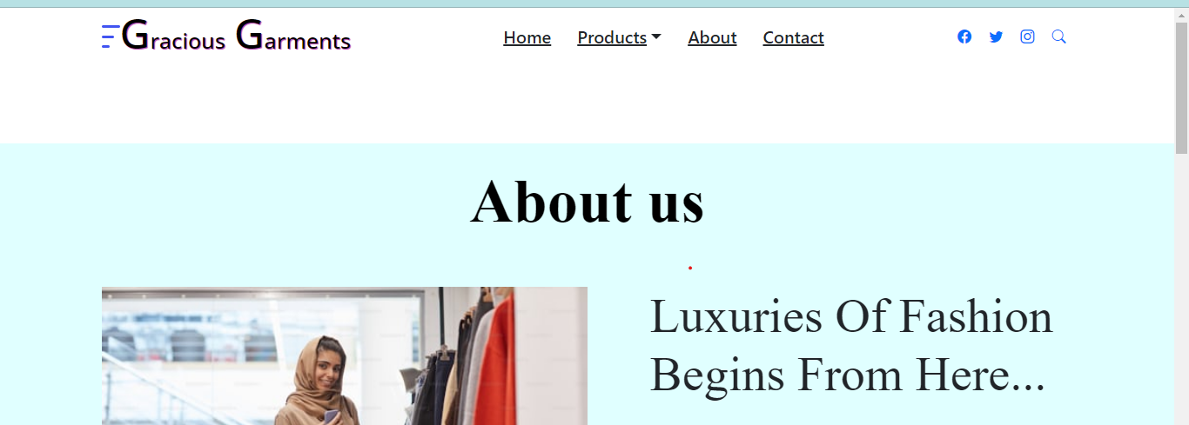** 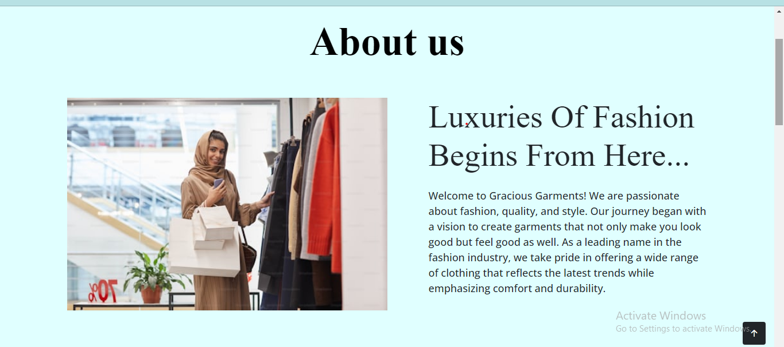 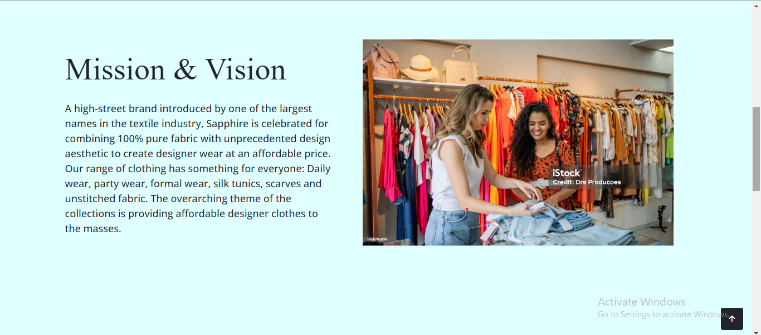 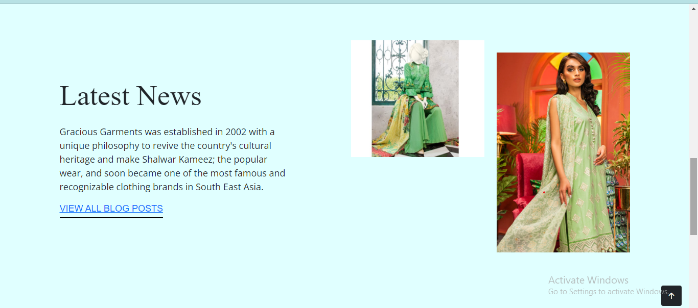

**CONTACT US**

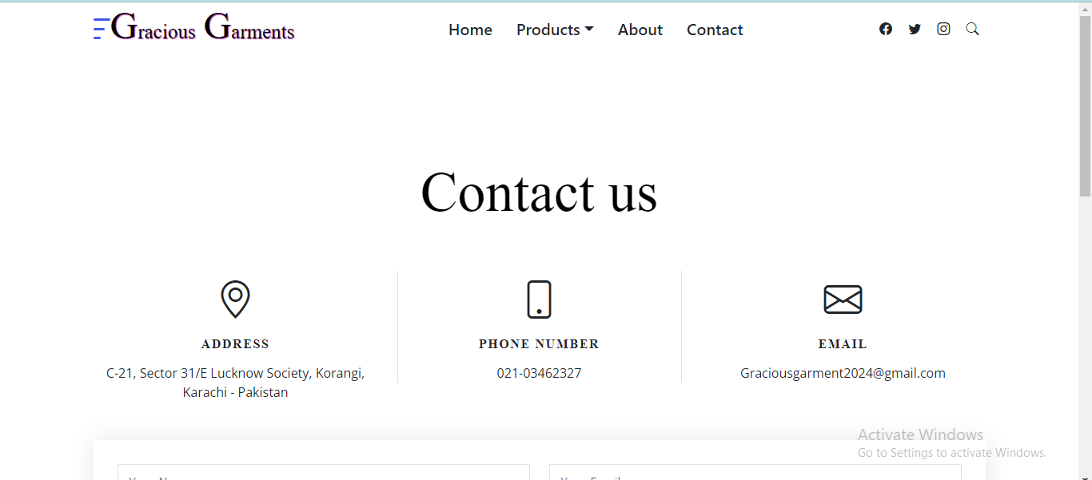 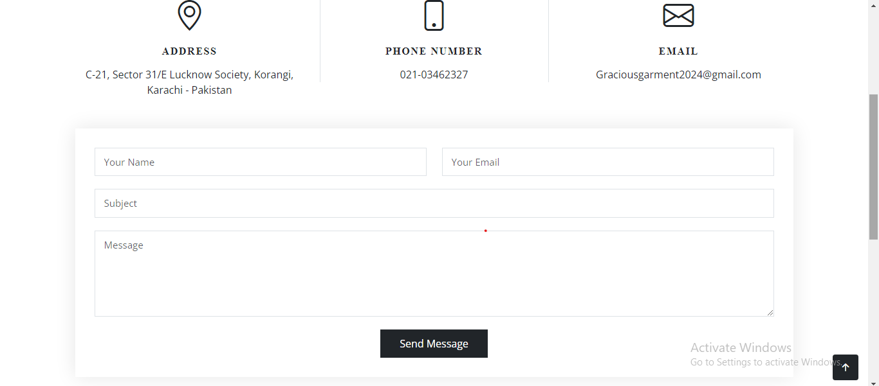

**BUY NOW** 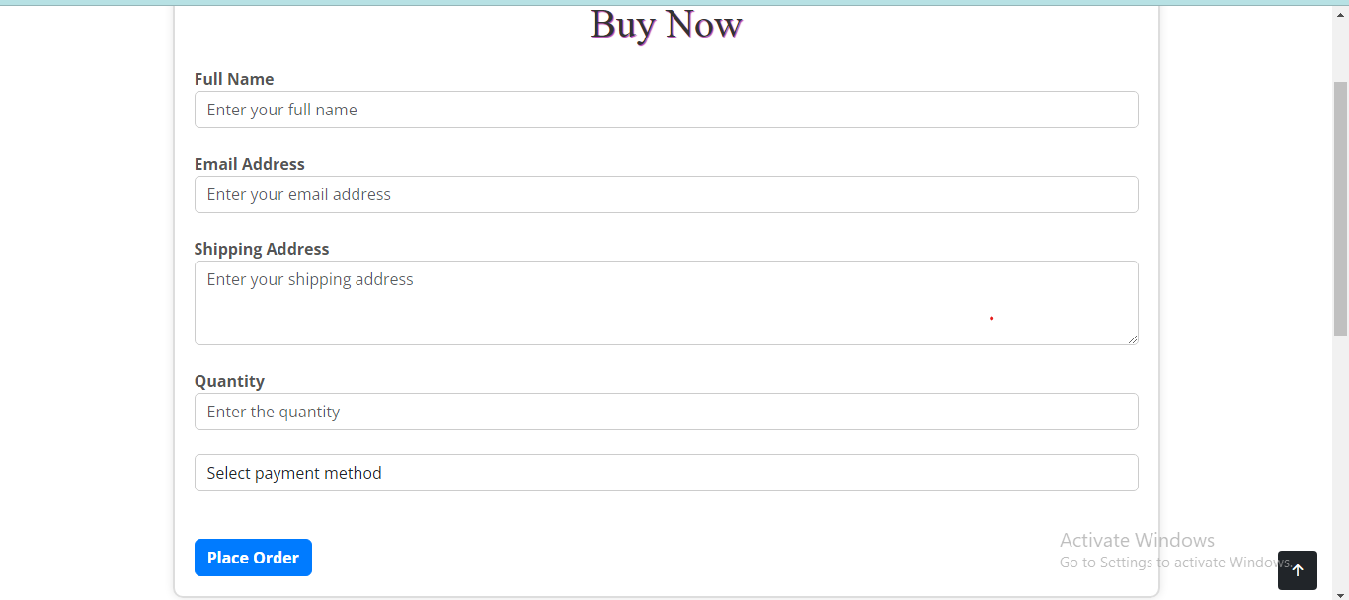

**Requirements Specification:**

**1. Home Page:**

The home page will serve as the landing page for the website and should be designed to be visually appealing and user-friendly. The following elements should be included:

* **Graphics**: High-quality images representing various garments for both men and women, with clear and attractive visuals.
* **Logo**: A suitable logo representing Gracious Garments, which should be placed prominently on the page to build brand recognition.
* **Navigation Bar**: A simple and intuitive navigation menu with links to different sections such as:
  + Home
  + Garments Catalog
  + Product Categories by Brand
  + Contact Us
  + About Us

**2. Product Details:**

The home page will also display different types of garments available for sale, with relevant product details:

* **Garment Sections**: Different categories for men's and women's garments with clear sectioning.
* **Product Images**: High-quality images of each garment, showing various angles and zoom features where applicable.

**3. Menu and Navigation:**

A well-organized menu should be provided for seamless navigation across the website. This will include:

* **Introduction to Garments**: A brief description of the types of garments available, such as formal, casual, and accessories.
* **Location**: A link to the shop’s physical location using a Google Maps embed (Geo-location support).
* **Additional Information**: Links to product features, reviews, or any other necessary details.

**4. Categorization of Products:**

The website should be able to categorize products based on the brands. Users can easily view products from a specific brand by clicking on the appropriate menu option or link. The menu should include:

* **Brand Names**: A clickable list of brand names like "Van Heusen," "Sapphire," etc.
* **Brand-Specific Products**: Upon selecting a brand, the website will display a list of products from that specific brand.

**5. Brand Selection & Display:**

* **Product Listings**: When a user selects a brand, a list of products from that brand should be shown. Each product will have:
  + Product name
  + Price
  + Size and color options
  + Short description or features
  + "Buy Now" link

**6. Product Features:**

* **Brief Summary on Website**: Each product will have a brief summary of key features listed directly on the website.
* **Detailed Features (Downloads)**: More detailed product features will be stored in individual Word documents. Users will have the option to either view or download these documents for further information.

**7. Product Comparison:**

* **Comparison Feature**: The website will include a feature where users can compare different products. This will include:
  + **Similar Products**: Products from the same brand or different brands with similar features can be compared side by side.
  + **Comparison Tool**: A clear and simple comparison tool that shows product specifications and features side by side to help users make informed decisions.

**8. Contact Us Page:**

* **Company Information**: The contact page will contain the following:
  + **Address**: “C-21, Sector 31/E Lucknow Society, Korangi, Karachi - Pakistan”
  + **Email**: A clickable email link that opens the local mail client with the email pre-filled. The email address will be “[Graciousgarment2023@gmail.com](mailto:Graciousgarment2023@gmail.com)”.
  + **Contact Form (Optional)**: An additional contact form can be included where users can submit inquiries.

**Hardware and Software Requirements**

**Hardware Requirements:**

* **Minimum System Requirements**:
  + **Processor**: Pentium 166 MHz or better.
  + **RAM**: At least 64MB or better.
  + **Display**: A monitor capable of displaying web pages correctly.
  + **Internet Connection**: Required for accessing the website and downloading necessary files.

**Software Requirements:**

* **HTML Editors**:
  + Notepad or an HTML editor like CoffeeCup for basic coding.
  + Alternatively, a more advanced editor like **Dreamweaver** or **Figma** can be used for designing the website layout.
* **Web Technologies**:
  + **Frontend Frameworks**: Angular, Angular JS, React, or Bootstrap for building the website’s frontend.
  + **HTML5** for semantic markup.
  + **CSS3** for styling the website.
  + **JavaScript** for dynamic functionality and interactivity.
  + **Geolocation** API for displaying the shop’s location on Google Maps.
* **Browsers for Testing**:
  + Ensure that the website works across all major browsers including:
    - **Chrome**
    - **Firefox**
    - **Internet Explorer (IE)**
    - **Microsoft Edge**
* **Content Management Tools**:
  + **MS Word** to store detailed product features for download.

**Conclusion:**

The Gracious Garments website will provide an engaging and efficient platform for customers to browse through different garment options, compare products, and make purchases easily. By incorporating essential features like product categorization, a product comparison tool, downloadable product specifications, and a clear "Contact Us" page, the website will enhance the customer experience. The use of modern web technologies will ensure the website is functional across all major browsers and is fully responsive, making it accessible for users across different devices.

The implementation of the geolocation feature and an interactive product catalog will make the website not only informative but also convenient for customers. With a well-structured and user-friendly interface, Gracious Garments can successfully tap into the growing e-commerce market and expand its reach beyond traditional advertising methods.